BRACT’s
Vishwakarma Institute of Technology, Pune
Practical Implementation Sheet
Department: CSE-AI Semester: 5 Academic Year: 2026-27
Division: E Batch: 3 Practical No: 1
Roll no: 71 PRN No: 12415150 Name: RAJ SONUNE
Subject Name : Deep Learning

Problem Statement : Install and configure TensorFlow/Keras in Google Colab. Load the MNIST handwritten digit dataset and perform data preprocessing, including normalization, train-test split verification, and visualization of sample images and class distribution.

Code : 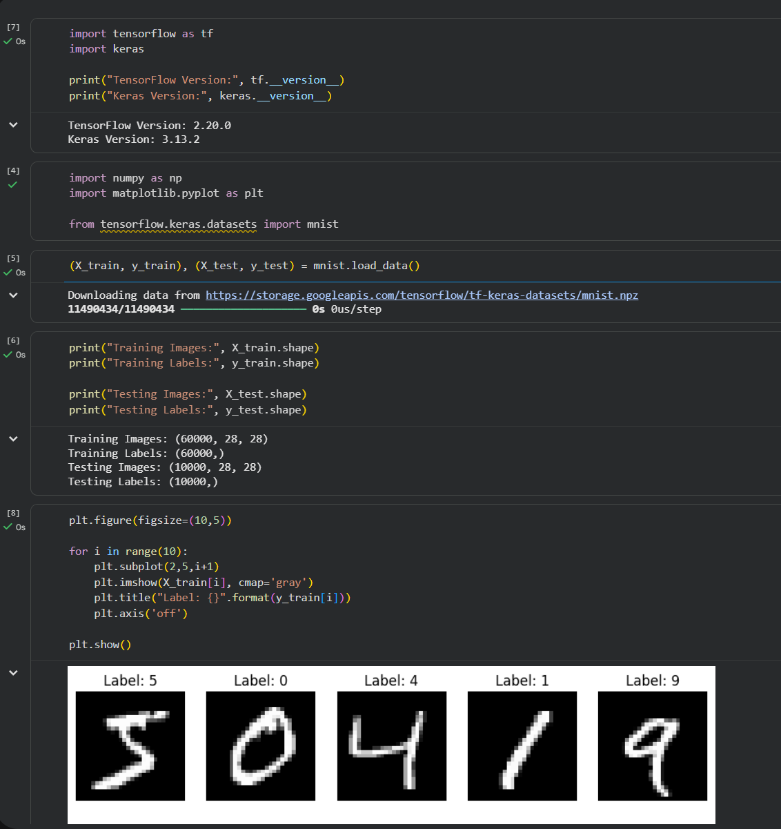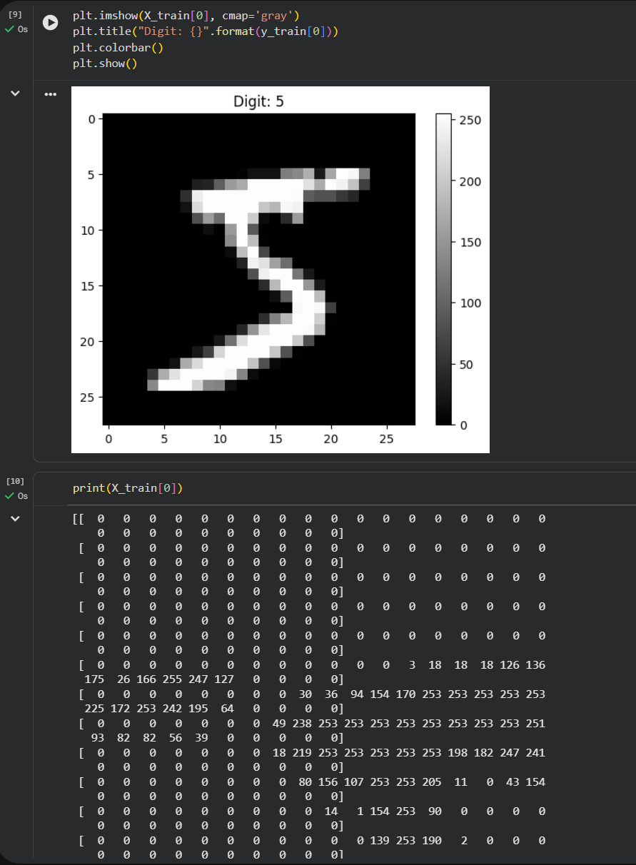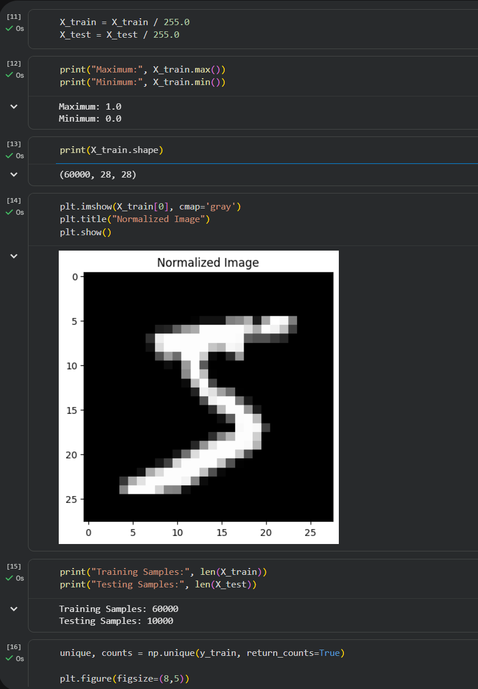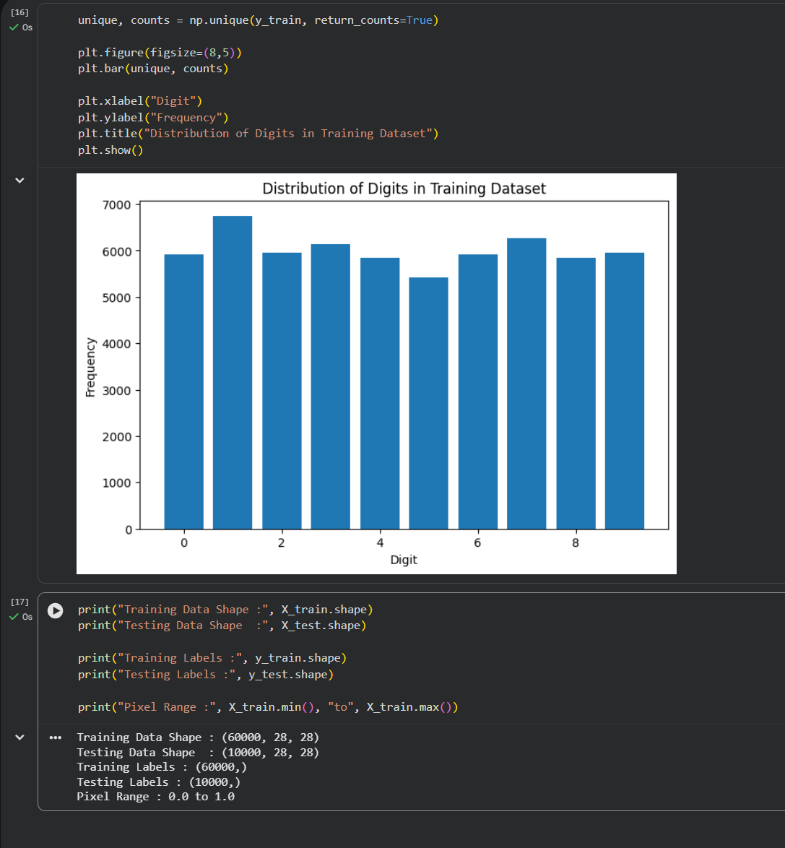

- Output : TensorFlow Version: 2.xx.x
- Keras Version: 3.xx.x
- Training Images: (60000, 28, 28)
- Training Labels: (60000,)
- Testing Images: (10000, 28, 28)
- Testing Labels: (10000,)
- Maximum Pixel Value after Normalization: 1.0
- Minimum Pixel Value after Normalization: 0.0
- Training Samples: 60000
- Testing Samples: 10000
- Training Data Shape : (60000, 28, 28)
- Testing Data Shape : (10000, 28, 28)
- Training Labels : (60000,)
- Testing Labels : (10000,)
- Pixel Range : 0.0 to 1.0
TensorFlow and Keras were successfully configured in Google Colab. The MNIST dataset was loaded, preprocessed by normalizing pixel values to the range 0–1, the predefined train-test split was verified, and the dataset was successfully visualized using sample images and a class distribution graph. This confirms that the dataset is ready for training machine learning or deep learning models.

